El laberinto del Fauno

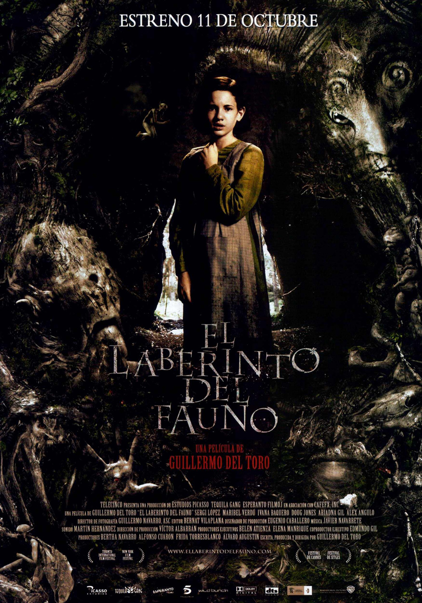

Investigaciones preparatorias

La Guerra Civil Española (17 julio 1936 – 1 abril 1939)
El 14 de abril 1931 Alfonso XIII, el rey de España, fue exiliado a Italia con su familia y un gobierno republicano se formó. Sin embargo, esta Segunda República Española estaba muy inestable a causa de las divisiones entre las clases sociales y sus correspondientes ideas políticas. Tras cuatro elecciones generales y cambios de gobierno en cinco años, los líderes del ejército decidieron tomar control de la situación y dieron un golpe de estado. Sin embargo, la clase obrera se sublevó en apoyo del gobierno republicano, lo que provocó el estallo de la Guerra Civil.

Durante la Guerra, los españoles se dividían en dos bandos: los nacionalistas y los republicanos. Ambos bandos cometieron actos de violencia atroces y mataron a gente inocente. No obstante, estos bandos se formaban de varias facciones. Abajo hay una lista de las facciones diferentes. Decide si cada una es nacionalista o republicana y escíbela en la columna apropiada de la tabla.

Nacionalistas | Republicanos
Los anarquistas
Los monarquistas
La Iglesia Católica
Los comunistas
Las brigadas internacionales (más de 30.000 extranjeros, generalmente comunistas)
El ejército
Los terratenientes
Los obreros de la industria
Los nacionalistas vascos
Los nacionalistas catalanes
Los liberales
La mayoría de los campesinos
La mayoría de los empresarios
La mayoría de la clase media educada

La Dictadura de Francisco Franco (1 abril 1939 – 20 noviembre 1975)

Mira las dos listas de la tabla. Según ellas, ¿por qué crees que los nacionalistas ganaron la Guerra Civil?

La dictadura de Francisco Franco

Durante los primeros años de la dictadura, época en la que se sitúa El Laberinto del Fauno, las medidas que utilizó Franco y su gobierno para controlar a la población eran bastante brutales. Haz tu propia búsqueda y encuentra definiciones/descripciones de los siguientes términos y leyes:
La ley de responsabilidades políticas

El Fuero de los Españoles

Los años de hambre

La sección femenina

La tradición de los cuentos de hadas de los Hermanos Grimm

(reading comp)

Clip based activities

Activity 1

Opportunity: The audience is introduced to the main characters for the first time when Ofelia and Carmen travel to the mill where Capitán Vidal and his troops are based.

Objective: To extend students’ vocabulary for personal description and examine how the director implies these characteristics implicitly

Excerpt from film: 02.34 > 08.51

Exercise: In small groups, make a table/mind map for each character (Ofelia, Capitán Vidal, Carmen and Mercedes). Think of adjectives that describe your impressions of each one and justify your selections with evidence from the extract. Don’t forget to consider sound effects, sound track, costumes and camera shots/angles as well as dialogue (or lack of it). Compare your group’s findings with another group’s. How are they similar? How are they different? Whole class feedback: What techniques has Guillermo del Toro used to think about the characters in the way we do?

Activity 2

Opportunity: Ofelia tells a dark fairy tale to her unborn brother.

Objective: To start examining the symbolism used in the film and create a fairy tale

Excerpt from film: 12.41 > 13.51

Exercise 1: Having watched the extract, read the corresponding part of the screen play and answer the following questions:
- What messages does the fairytale communicate?
- What could its various images represent?
- How do we know that she is relating the story to real events?

Exercise 2: Using the techniques discussed in Exercise 1, create your own fairy tale (on own or in small groups) to represent and express your opinion about an event through symbolism. Read the stories out to the class/record them and play them back and see if the other students can work out which event you have written about.

Activity 3

Opportunity: Ofelia is led into the labyrinth by the fairy and encounters the Fawn for the first time. How does Guillermo del Toro make the Fawn so sinister? Is this sinister feeling alleviated or intensified the second time we see the Fawn?

Objective: To look at the techniques that actors and directors use to portray characters in a certain way and examine the use of make up, sound effects (sound track?) to this end.

Grammar: The use of the “vos” form of the verb

Excerpts from film: 19.03 > 23.34 and 41.58 > 44.06

Exercise 1: Grammar: The “vos” form of the verb to address royalty/members of the aristocracy (Spain). Refer to its use instead of “tú” in Argentina.

Exercise 2: Read the parts of the screen play that correspond to the extracts. How does the Fawn come across? Watch the clips and make notes on the following:

- Doug Jones’ interpretation of the character
- Pablo Adán’s interpretation of the character
- Ivana Baquero’s portrayal of Ofelia’s reaction to him
- The make up
- The sound effects
- The sound track

How do these aspects change our perception of the Fawn? What effect does that in turn have on the atmosphere/suspense of the film? Create a thinking map to illustrate your thoughts and present them to the class.

Exercise 3: Could the Faun be presented in a different way? Pair off and choose one of the two extracts. One plays Ofelia and the other the Fawn. Each pair should try to portray the Fawn in a different way:
- Caring
- Shy
- Arrogant
- Ambivalent
- Aggressive
- Scared
- Depressed

Activity 4

Opportunity: a) Capitán Vidal’s morning routine, followed by an interaction between him and Mercedes.
b) Capitán Vidal holds a dinner party for important people in the army and the town. During the dinner party, Carmen tells the story of how she and Vidal met and married. The doctor’s wife and the mayor’s wife seem incredulous and Vidal ridicules Carmen and the story. An army officer also tells a story about meeting Capitán Vidal’s father and how he died on the battlefield, leaving his son his watch set to the time of his death (which Vidal wears all the time and takes a huge amount of care over); however, Capitán Vidal denies that his father ever owned a watch.

Objective: To understand the complicated character of Capitán Vidal better and look at techniques used by actors to portray emotions and feelings to the audience.

Excerpts from film: 23.34 > 24.47 and 39.27 > 40.54

Exercise 1: Watch the first extract and list the activities in Capitán Vidal’s morning routine. What do they tell us about him? What are his vices? What is his relationship with Mercedes like? How is all this portrayed? Is there a point that has a particularly strong effect on the audience? How do the actors and the director put this feeling across?

Exercise 2: Watch the second extract, focussing on the section where Carmen tells her story of how she and Vidal met and married. Do you agree with the doctor’s wife and the mayor’s wife that their meeting was unlikely to have been coincidental? What do you think really happened? Write a short piece in groups to tell the story of what really happened from Capitán Vidal’s point of view.

Exercise 3: Watch the second extract again. What are Capitán Vidal’s reactions to the two stories? What techniques do Sergi López and Guillermo del Toro use to portray Capitán Vidal’s feelings non-verbally? In small groups, try to re-make and film the section where Carmen tells the story of how she met the captain, but this time focus on the doctor’s wife and the mayor’s wife. Try to use some of the techniques you have just discuss to portray their feelings non-verbally.

Extra: Add your findings to the thinking map that you made about Capitán Vidal initially. How have your impressions changed since the beginning of the film?

Activity 5

Opportunity: The first two of Ofelia’s tasks: the Toad and the Pale Man

Objective: To extend students’ vocabulary for personal description and examine how the director implies these characteristics implicitly.
To look at the creation of fear, tension and suspense in film

Excerpts from film: Task 1: 29.54>31.54 and 34.04>36.20
Task 2: 53.37>1.0.22

Exercise 1: Watch the clips and answer the following questions:
Which task do you think is the most difficult? Why?
Which task do you think is the scariest? Why?
What do the two tasks have in common? In what ways are they different? In small groupls, make a thinking map to illustrate this.

Exercise 2: Watch the tasks again. Discuss how tension is created in each one and make notes of the techniques is small groups on a copy of these sections of the screen play. (Don’t forget to include: non-verbal responses, sound effects, sound track, make-up, lighting). Discuss your findings as a class and make a definitive list.

Exercise 3: Create your own 3rd task in groups using a concept that was cut from Guillermo del Toro’s original plan: The Wooden Man. What does he look like? How does he move? Why is he dangerous? What must Ofelia do to get past him? Make sure you include the commonalities from tasks 1 and 2 and, where possible, the methods of tension creation from the list.
Extension: Write your own short screenplay for this new task.

Extra: Watch the first part of the first task again. Look specifically at Ofelia’s costume, the camera angles used and the effect they create. What do they remind you of? Why do you think this has been used?

Activity 6

Opportunity: Doctor Ferreiro defies Capitán Vidal’s order and kills Tarta (at his request) before the captain has finished torturing him for information. Capitán Vidal shoots the doctor.

Objective: To examine the theme of free will in the film
To look at the emotive aspects of the scene

Excerpt from film: 1.20.53>1.22.05

Exercise 1: Watch the extract. How does Doctor Ferreiro come across? Why? How does Capitán Vidal come across? Why? Why is this scene so sad? Watch the extract for a second time with the sound off. How is it different?

Exercise 2: Watch the extract again? Why is it that Capitán Vidal cannot understand Doctor Ferreiro’s actions? Divide the class into groups of 3 or 4. Half the groups should think of reasons to back up Capitán Vidal’s beliefs and actions and the other half should do the same for Doctor Ferriero. Next put the class into pairs where one person is Capitán Vidal and the other Doctor Ferreiro. Each pair should discuss/argue their point of view. Follow up with a class discussion about the outcome of these discussions in pairs.

Activity 7

Opportunity: Pedro and Mercedes corner Capitán Vidal after he has killed Ofelia. Knowing he is about to die, Vidal hands his son to Mercedes and asks her to tell him what time and how he dies but she refuses and tells him that his son won’t even know that he existed. Pedro then shoots Vidal.

Objective: To examine the theme of revenge and the use of violence in film

Excerpt from film: 1.42.40 > 1.53.59

Exercise 1: During this extract there are two fatal shootings that are shot and portrayed very differently. Watch the extract a couple of times and note down these differences. Do you think that this scene is too violent? Why (not)? Compare your notes with your partner and then discuss your findings as a class.

Exercise 2: Mercedes and the rebels clearly take revenge on Capitán Vidal in this extract. Do you think their actions are acceptable given the circumstances? Divide the class into 4 groups, two that will argue that the revenge on Capitán Vidal is acceptable and two that will argue that it is not. Take some time to prepare your arguments before having the debate in the following format:

Group 1:
For present (Group 2 take notes)
Against present (Group 2 take notes)
Questions from the floor (Group 2)

Group 2:
For present (Group 1 take notes)
Against present (Group 1 take notes)
Questions from the floor (Group 1)

